Capteur de distance slideshow
- Porteur(s) du projet : Mathilde Verdu Ibañez, Ugo Berzal, Chloé Chapal (DSAA 1) & Damien MUTI (Prof. de Numérique)
- Date : 03/2021
- Contexte :
- Fichiers :
- Liens :
- Capteurs/Actionneurs :
  - Capteur de distance

Intentions : explication du projet et objectifs
Intentions Chloé : Tableaux vivants avec capteur de distance
Intentions Mathilde : Digital Dating Burnout

Plans et schémas de fonctionnement
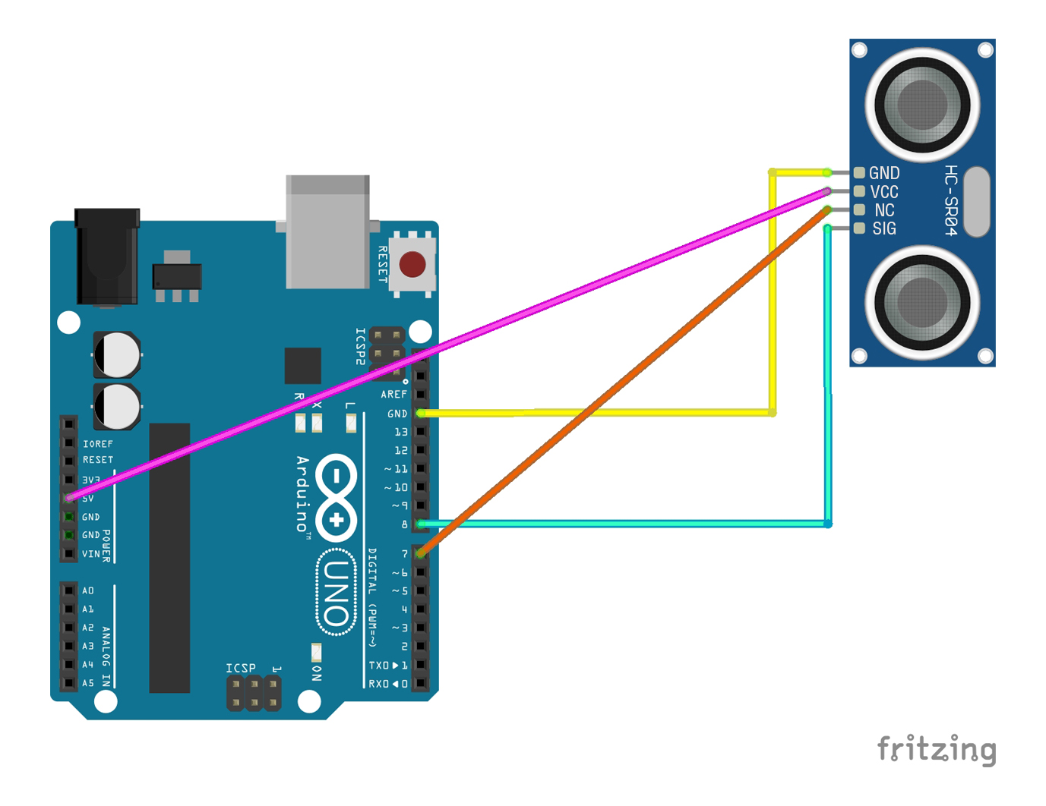

Programmes
ARDUINO
#include “Ultrasonic.h”
Ultrasonic ultrasonic(7);
long distance=0; / variable qui stoke la valeur de la distance
int firstSensor = 0; / first analog sensor
int inByte = 0; / incoming serial byte
void setup() {
// start serial port at 9600 bps:
Serial.begin(9600);
while (!Serial) {
; // wait for serial port to connect. Needed for native USB port only
}
establishContact(); // send a byte to establish contact until receiver responds
}
void loop() {
// if we get a valid byte, read analog ins:
if (Serial.available() > 0) {
// get incoming byte:
inByte = Serial.read();
// lecture de la distance
distance = ultrasonic.MeasureInCentimeters();
// conversion de la valeur en un octet
firstSensor = map(distance,0,400,0,255);
// send sensor values:
Serial.write(firstSensor);
delay(200);
}
}
void establishContact() {
while (Serial.available() <= 0) {
Serial.print('A'); // send a capital A
delay(300);
}
}
PROCESSING
import processing.serial.*;
/ graphisme
int bgcolor; / Background color
int fgcolor; / Fill color
int xpos, ypos; / Starting position of the ball
int distance;
PImage[] tabImages;
int NImages = 3;
/port serie
Serial myPort; / The serial port
int serialInArray; / Where we'll put what we receive
int serialCount = 0; / A count of how many bytes we receive
boolean firstContact = false; / Whether we've heard from the microcontroller
void setup() {
size(600, 485); // Stage size
noStroke(); // No border on the next thing drawn
// Set the starting position of the ball (middle of the stage)
xpos = width/2;
ypos = height/2;
// Print a list of the serial ports, for debugging purposes:
printArray(Serial.list());
// I know that the first port in the serial list on my mac
// is always my FTDI adaptor, so I open Serial.list()[0].
// On Windows machines, this generally opens COM1.
// Open whatever port is the one you're using.
String portName = Serial.list()[9];
myPort = new Serial(this, portName, 9600);
// espace HSB des couleurs
colorMode(HSB);
//creation tableau images
tabImages=new PImage[NImages];
for (int i=0; i<NImages; i++) {
tabImages[i]= loadImage("images"+i+".jpg");
}
}
void draw() {
background(bgcolor);
// test distance
if (distance >= 0 && distance < 50) {
image(tabImages[0], 0, 0, width, height);
} else if (distance >= 50 && distance < 100) {
image(tabImages[1], 0, 0, width, height);
} else if (distance >= 100 && distance < 150) {
image(tabImages[2], 0, 0, width, height);
} else {
image(tabImages[0], 0, 0, width, height);
//fill(0);
//rect(0, 0, width, height);
}
//fill(fgcolor, 255, 255);
// Draw the shape
//ellipse(xpos, ypos, 20, 20);
}
void serialEvent(Serial myPort) {
// read a byte from the serial port:
int inByte = myPort.read();
// if this is the first byte received, and it's an A,
// clear the serial buffer and note that you've
// had first contact from the microcontroller.
// Otherwise, add the incoming byte to the array:
if (firstContact == false) {
if (inByte == 'A') {
myPort.clear(); // clear the serial port buffer
firstContact = true; // you've had first contact from the microcontroller
myPort.write('A'); // ask for more
}
} else {
// Add the latest byte from the serial port to array:
distance = (int) map(inByte, 0, 255, 0, 400); // remplir le donnée "utile"
// print the values (for debugging purposes only):
println("valeur lue sur le port Série = " + distance);
// Send a capital A to request new sensor readings:
myPort.write('A');
// Reset serialCount:
}
}

Réalisation de la maquette

